Molecular Graphics using PyMOL – Tutorial Quiz
WSBS PyMOL Tutorial Jonathan Ipsaro October 24, 2018

1. Duplicate the following image of PDB entry 3U4X

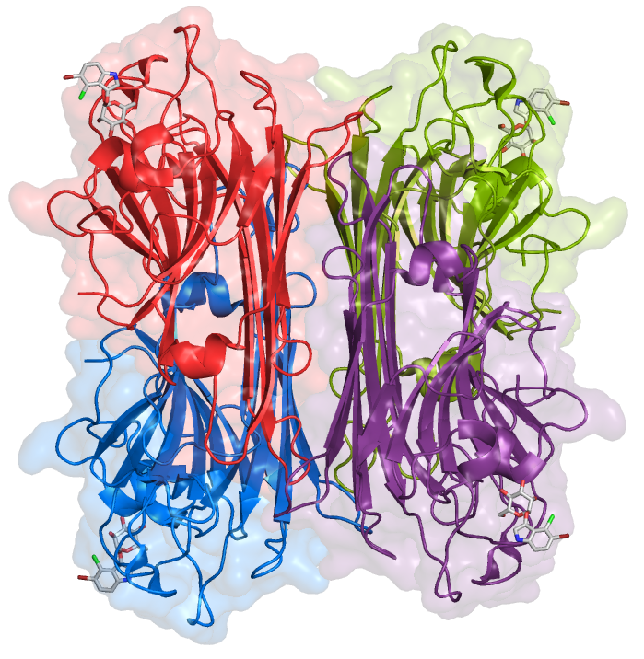
Please note:
There are no shadows
The surface transparency is at 80%
Specific coloring of the bound ligands
The view is orthoscopic (not perspective)

2. Calcium binds to this molecule. What are the amino acids involved?

3. Manganese binds to this molecule. What are the amino acids involved?

Answers:

2. Calcium binds to this molecule. What are the amino acids involved?
Tyr12, Asn14, Asp19

3. Manganese binds to this molecule. What are the amino acids involved?
Asp10, Asp19, His24

