Molecular Graphics using PyMOL – Tutorial Quiz
WSBS PyMOL Tutorial Jonathan Ipsaro October 24, 2018

- Duplicate the following image of PDB entry 6D41.

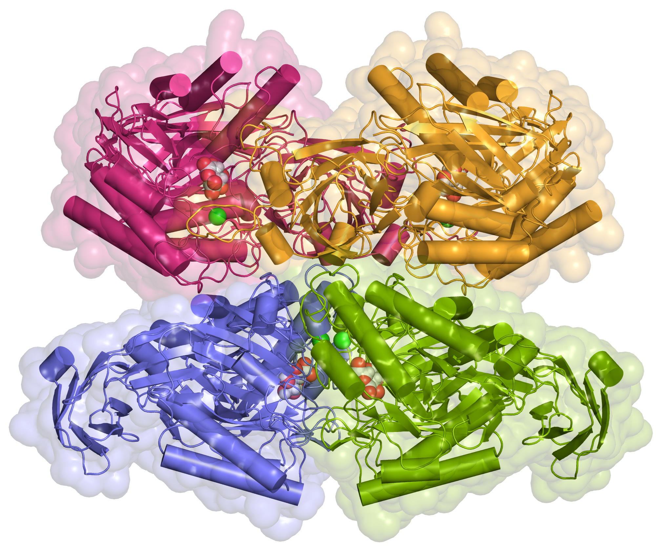

- What is the resolution of this structure?

- What are the unit cell dimensions?

- What was the crystallization condition?

- Where were the diffraction data collected?

